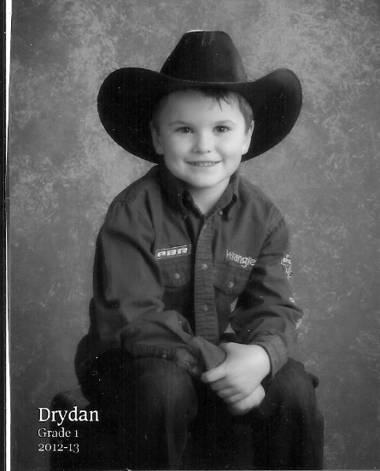
Drydan Griffith is excited to be the King for the Twin Valley Riding Club for 2013.

He is the son of Robert and Lynette Griffith and brother to Paige, Dawson and Sheradyn. Drydan is 6 yrs old, lives in Stockholm and is in grade 1 at Macdonald school.

Drydan loves riding his horse Reba. He belongs to the Bangor 4H Club as well as the Melville Little Slickers club. He really wants to be a Bull rider and his big buddy Mark Fraser has said he’ll teach him how – Look out Bull Riders!

In the winter Drydan enjoys playing hockey, he likes defence and goalie position the best, likes downhill skiing and ski-doing too.

Drydan loves animals and would like to be an animal trainer of some kind – maybe dolphins, when he grows up. As well as being a cowboy.

Drydan will be representing TVRC at the 2013 Saskatchewan Riding Club Association finals in the fall. Drydan and the TVRC will be raising funds throughout the year to be able to send club members to this event and to provide prizes etc for this event. Drydan will also collect points on the sponsorships and funds he receives and could win a saddle if he has highest points collected.

Please show your support.

Good Luck and Have Fun Drydan!

